- IP Routing & Protocols

Q.1 Draw a simple network diagram showing three devices (like your phone, a friend's laptop, and a smart TV) connected through a router, and label the IP addresses for each device and the router's interfaces?

Answer

- Network Diagram with IP Address
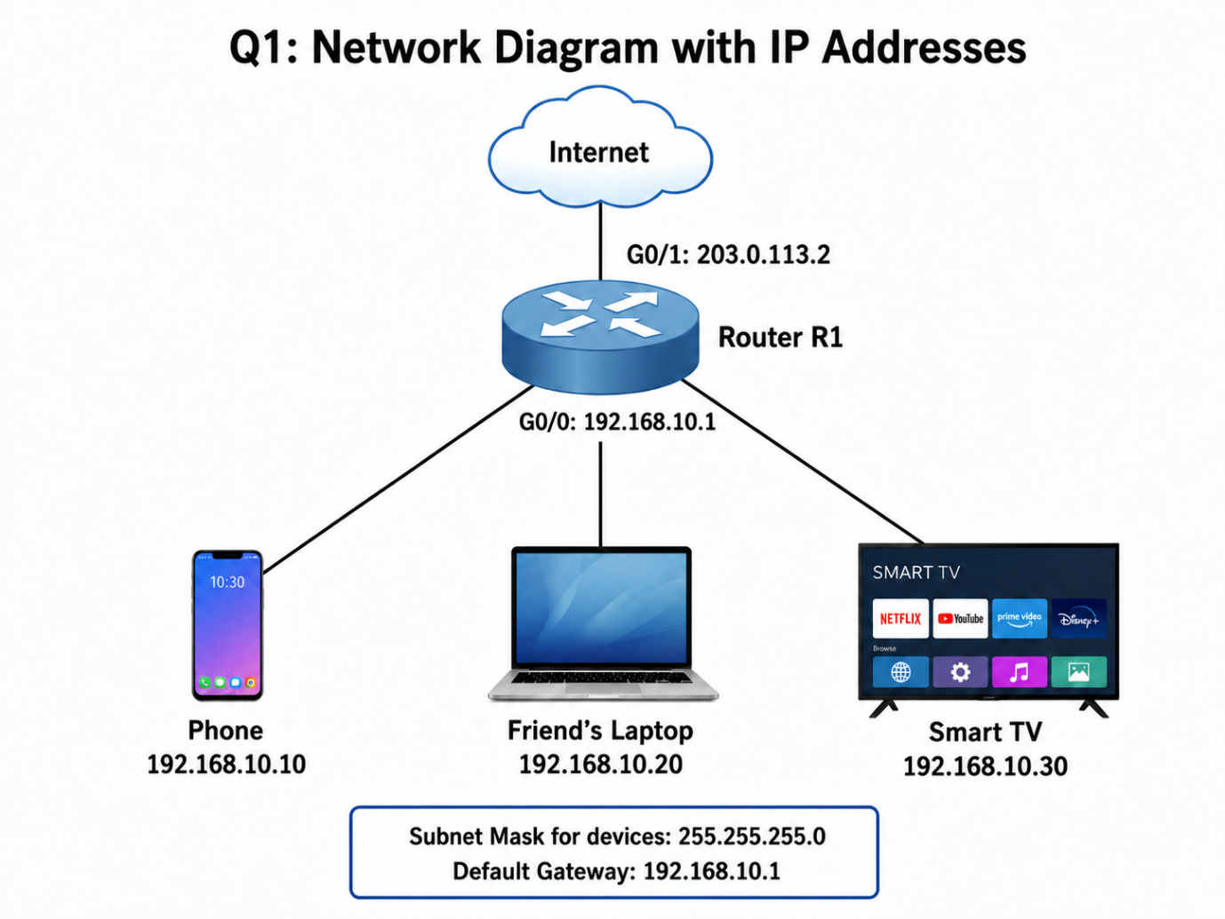

- Explanation:
The diagram shows three devices connected through Router R1. The phone uses IP address 192.168.10.10, the friend’s laptop uses 192.168.10.20, and the Smart TV uses 192.168.10.30. The router’s G0/0 interface uses 192.168.10.1 as the local network gateway, while G0/1 uses 203.0.113.2 to represent the connection toward the internet.

Q.2 Simulate manual IP routing by writing a step-by-step explanation of how a packet would travel from your laptop to a friend's computer in a different subnet, including which router(s) it passes through and how the routing decision is made.<br><br><em><strong>Hint:</strong> Use made-up IP addresses and show the routing table entries that would be checked at each hop.</em>?

Answer

- Manual IP Routing Between Two Different Subnets
Suppose my laptop is in one subnet and my friend’s computer is in another subnet.
My Laptop: 192.168.1.10/24
Default Gateway: 192.168.1.1
Router 1:
- G0/0: 192.168.1.1
- G0/1: 10.0.0.1
Router 2:
- G0/0: 10.0.0.2
- G0/1: 192.168.2.1
Friend’s Computer: 192.168.2.10/24
Default Gateway: 192.168.2.1
- Routing Table Entry on Router 1
- Destination Network: 192.168.2.0
- Subnet Mask: 255.255.255.0
- Next Hop: 10.0.0.2
- Routing Table Entry on Router 2
- Destination Network: 192.168.1.0
- Subnet Mask: 255.255.255.0
- Next Hop: 10.0.0.1

- Step-by-Step Packet Travel
- My laptop wants to send data to 192.168.2.10.
- It checks and finds that the destination is not in its own 192.168.1.0/24 subnet.
- The packet is sent to the default gateway 192.168.1.1 (Router 1).
- Router 1 checks its routing table and finds that 192.168.2.0/24 can be reached through next hop 10.0.0.2.
- Router 1 forwards the packet to Router 2.
- Router 2 checks its routing table and sees that 192.168.2.0/24 is directly connected.
- Router 2 forwards the packet to my friend’s computer at 192.168.2.10.

- Result:
The routers use their routing tables to choose the correct path and deliver the packet from one subnet to another.

Q.3 Create a routing table for a fictional Zomato-style delivery network with three branches in different cities, each on a different subnet. Specify the network address, subnet mask, next hop, and interface for each route?

Answer

- Routing Table for a Zomato-Style Delivery Network
Suppose a Zomato-style company has three branches in different cities, and each branch uses a different subnet.

Branch | Network Address | Subnet Mask | Next Hop | Interface
- Delhi | 192.168.10.0 | 255.255.255.0 | Direct | G0/0
- Mumbai | 192.168.20.0 | 255.255.255.0 | 10.0.0.2 | G0/1
- Banglore | 192.168.30.0 | 255.255.255.0 | 10.0.0.6 | G0/2

- Explanation:
Each city branch has its own subnet. The router checks the routing table to decide where to forward the packet. The Delhi network is directly connected, while traffic for Mumbai and Bangalore is sent to the correct next-hop router through the specified interface.

Q.4 Compare static routing and dynamic routing protocols (like RIP or OSPF) by listing 3 pros and 3 cons of each, using examples from real-world apps or services you use (e.g., how a food delivery app might benefit from dynamic routing)?

Answer

- Static Routing vs Dynamic Routing
Point | Static Routing | Dynamic Routing
- Configuration | Routes are entered manually | Routes are learned automatically
- Network Changes | Must be updated manually | Updates automatically when the network changes
- Best For | Small and simple networks | Large and changing networks

- Static Routing – Advantages
- Simple to understand in small networks.
- Uses less CPU and network bandwidth.
- Gives the administrator full control over the route.
- Static Routing – Disadvantages
- Routes must be updated manually.
- Difficult to manage in large networks.
- Does not automatically choose another path if a link fails.
- Example:
A small office or warehouse with only a few fixed networks can use static routing because the network does not change often.
- Dynamic Routing – Advantages
- Routes are learned and updated automatically.
- Can find another path if one route fails.
- Suitable for large networks with many routers.
- Dynamic Routing – Disadvantages
- More difficult to configure.
- Uses more CPU, memory, and bandwidth.
- Requires knowledge of protocols such as RIP or OSPF.
- Example:
A large food-delivery service like Zomato can benefit from dynamic routing because its offices, servers, and data centers may have multiple network paths. If one path fails, protocols such as OSPF can automatically select another route.

Q.5 Use ChatGPT or another AI tool to generate a sample configuration for setting up OSPF routing between two routers, then explain in your own words what each configuration line does.<br><br><em><strong>Hint:</strong> Paste the AI-generated config and annotate each part with a short description.</em>?

Answer

- OSPF Routing Between Two Routers
I used ChatGPT to generate the following sample OSPF configuration for two Cisco routers.
- Network Setup
- Router 1 LAN: 192.168.1.0/24
- Router 2 LAN: 192.168.2.0/24
- Router-to-Router Network: 10.0.0.0/30
- OSPF Area: 0
Router 1 Configuration
enable
configure terminal

interface g0/0
ip address 192.168.1.1 255.255.255.0
no shutdown
exit

interface g0/1
ip address 10.0.0.1 255.255.255.252
no shutdown
exit

router ospf 1
router-id 1.1.1.1
network 192.168.1.0 0.0.0.255 area 0
network 10.0.0.0 0.0.0.3 area 0

end
Router 2 Configuration
enable
configure terminal

interface g0/0
ip address 192.168.2.1 255.255.255.0
no shutdown
exit

interface g0/1
ip address 10.0.0.2 255.255.255.252
no shutdown
exit

router ospf 1
router-id 2.2.2.2
network 192.168.2.0 0.0.0.255 area 0
network 10.0.0.0 0.0.0.3 area 0

end
- Explanation of the Configuration
- enable – Enters privileged EXEC mode.
- configure terminal – Opens global configuration mode.
- interface g0/0 – Selects the LAN interface.
- ip address – Assigns an IP address and subnet mask to the interface.
- no shutdown – Turns the interface on.
- interface g0/1 – Selects the interface connecting the two routers.
- router ospf 1 – Starts OSPF process number 1.
- router-id 1.1.1.1 / 2.2.2.2 – Gives each router a unique OSPF identification number.
- network 192.168.1.0 0.0.0.255 area 0 – Advertises Router 1's LAN through OSPF.
- network 192.168.2.0 0.0.0.255 area 0 – Advertises Router 2's LAN through OSPF.
- network 10.0.0.0 0.0.0.3 area 0 – Enables OSPF on the connection between the two routers.
- area 0 – Places the networks in the main OSPF backbone area.
- end – Exits configuration mode.
- Result:
After OSPF is configured, both routers automatically learn the route to the other router's LAN. This allows devices in 192.168.1.0/24 and 192.168.2.0/24 to communicate without manually adding static routes.

